Code Week is included in UN SDG good practices!

EU Code Week is now featured as a good practice on the United Nation’s Sustainable Development Goal 4 Knowledge Hub. The Hub is an online resource centre for news and commentary on the implementation of the UN’s 2030 Agenda for Sustainable Development and the Sustainable Development Goals (SDGs).

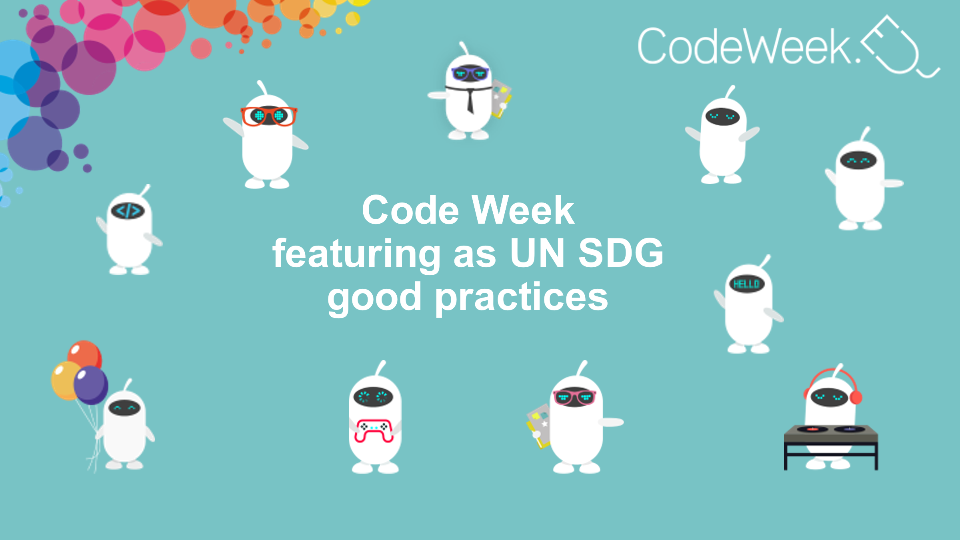

Introduction
One of the UN’s 17 SDGs, SDG 4 is about quality education and aims to provide children and young people with quality and easy access to education and other learning opportunities. SDG 4 seeks to ensure access to education through all stages of life and to increase the number of young people and adults who have the relevant skills for employment, decent jobs and entrepreneurship.

Why this is important
With its goal of bringing coding and digital literacy to everybody, but particularly young people, in a fun and engaging way, the EU Code Week ethos is fully aligned with that of SDG 4, and this is why it has been featured as a good practice. Code Week has been included as a good practice in the Hub’s thematic action track dealing with digital learning and transformation.

Who makes Code Week happen
In 2021, more than 4 million people in more than 80 countries around the world took part in EU Code Week. The average participant was 11 years old and 49% of participants in 2021 were women or girls. In total, 88% of EU Code Week events were organised by teachers and took place in schools.

It wouldn’t have been possible to reach this milestone without such an amazing Community of Teachers and Leading Teachers, Ambassadors, and Edu Coordinators, who keep spreading the Code Week values with the rest of the coding enthusiasts and encourage everyone to be involved in Code Week.

